The laboratory work 13
Let's start with an easy one. You want to show VanArsdel's sales (revenue) and units for each month and year in a single report. You choose to show this using two Matrix visualizations.
- Start with the “Lab 3 - Starting.pbix” file.
- In the navigation pane on the left, click Report.
- In the FIELDS list, on the right, click the Sales table.
- Drag the Total Sales field from the Sales table to the report to create a chart.
- In the FIELDS list, on the right, click the Date table.
- Drag the MonthName and Year fields from the Date table to the chart.
- In the VISUALIZATIONS list, click Matrix.
- In the VISUALIZATIONS list, in Rows, select MonthName, in Columns, select Year, and in Values, select Total Sales.
- Repeat Step 5 to 10 to add another chart, but this time, display the Total Units field in place of Total Sales.
- From the Home ribbon, click Text box.
- In the text box, type VanArsdel Sales and Units and resize and move the text box so that it appears as the title of the report.
- At the bottom of the screen, right-click Page 1, and click Rename Page.
- Type Sales and Units and press Enter.
You should have something similar to the below:
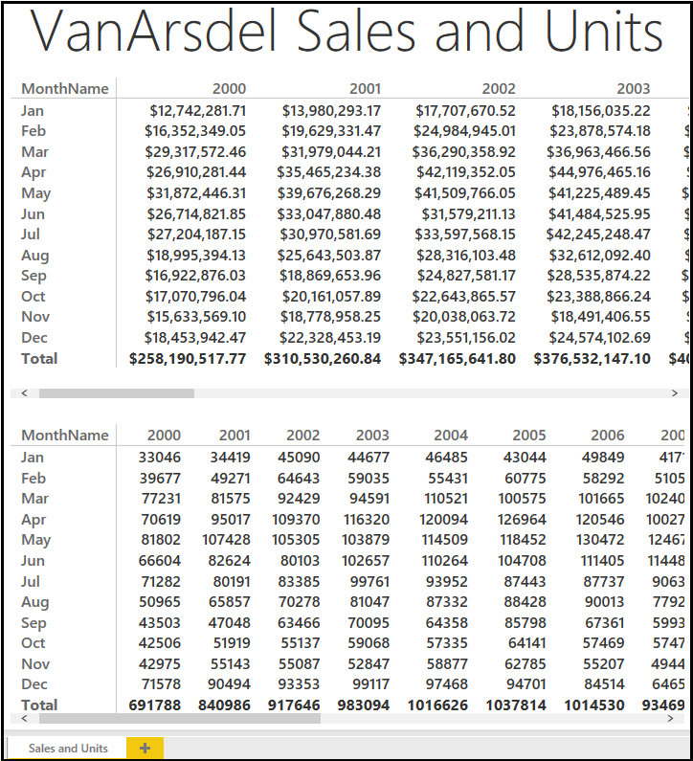
- Click Save, to save the Power BI file.

Exercise 7
Now that you have the big picture, let's start analyzing the data sales data by product category, segment and manufacturer.
- If it is not already open, open the Lab 3 - Starting.pbix file.
- Create a new report page by clicking New Page (+) at the bottom of the report view.
- Drag the Total Sales field from the Sales table to the report and create a chart.
- Drag the Category and Segment fields from the Products table to the chart.
- In the VISUALIZATIONS list, click 100% Stacked Bar Chart .
- In the VISUALIZATIONS list, in Axis, select Category, in Legend, select Segment, and in Value, select Total Sales.
- In the VISUALIZATIONS list, click the Format button.
- Click Data Labels.
- Set Data Labels to On.
- Set Value decimal places to 0.
- Drag the Total Sales field from the Sales table to the report and create another chart.
- Drag the Manufacturer field from the Manufacturers table to the chart.
- Modify the chart to use the Treemap visualization.
- Drag the MonthName field from the Date table to the report and create another chart.
- Modify the chart to use the Slicer visualization.
- Drag the Year field from the Date table to the report and create a chart.
- Modify the chart to use the Slicer visualization.
- Rename the report sheet to Sales Breakdown.
- Click Save, to save the Power BI file.
You should have something similar to the below:
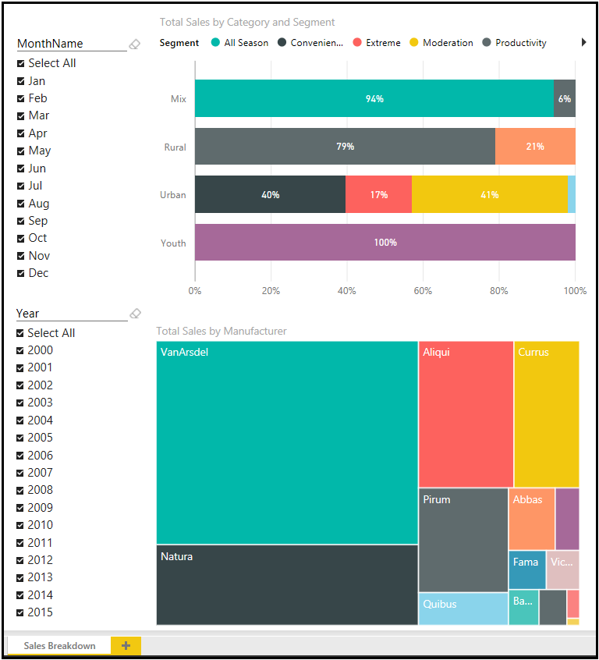
Exercise 8
You would like to know more about the relationship between total units and total sales by category and segment. You choose to analyze this using scatter chart.
- If it is not already open, open the Lab 3 - Starting.pbix file.
- Create a new report page by clicking New Page at the bottom of the report view.
- In VISUALIZATIONS, click Scatter Chart.
- Drag the Total Sales, Total Units, and YTD Sales fields from the Sales table to the chart.
- Drag the Category and Segment fields from the Products table to the chart.
- Drag the Year field from the Date table to the chart.
- Rename the report sheet to Sales Relationship.
- Ensure that the following fields are set in the visualization Details:
  - Details: Category
  - Legend: Segment
  - X Axis: Total Sales
  - Y Axis: Total Units
  - Size: YTD Sales
  - Play Axis: Year
- Click Save, to save the Power BI file.
You should have something similar to the below:
